User:

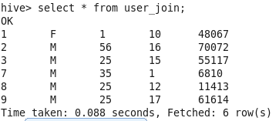

Rating:

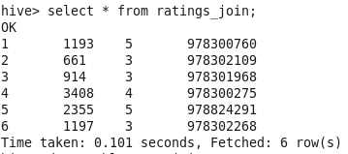

Movies:

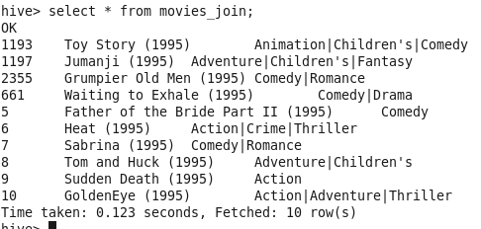

**Normal left semi-join without where clause:**

SELECT * FROM ratings_join r left semi JOIN user_join u ON r.userid = u.userid;

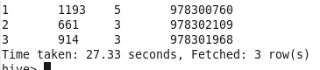

**Following query also returns the same result:**

SELECT * FROM ratings_join r LEFT semi JOIN user_join u ON r.userid = u.userid where r.movieid IS not NULL;

select r.userid,r.movieid,r.rating,r.timestamp_rating from ratings_join r join user_join u ON r.userid = u.userid ;

**Left semi join without where/ON clause:**

SELECT * FROM ratings_join r left semi JOIN user_join u;

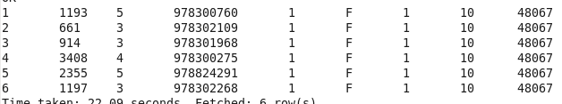

**Left semi-join without ON clause and reference to right table in where:**

SELECT * FROM ratings_join r LEFT semi JOIN user_join u where u.userid = 1;

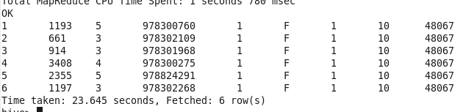

**Left semi join without on clause:**

SELECT * FROM ratings_join r LEFT semi JOIN user_join u where r.userid = 3;



Following Cartesian Join can also return the same result:

SELECT * FROM ratings_join r JOIN user_join u where r.userid = 3 AND u.usedid = 1;

**Left semi join without on clause and using IN:**

SELECT * FROM ratings_join r LEFT semi JOIN user_join u ON r.userid = u.userid where r.userid IN (1,2);



**Left semi join with where clause and use of OR:**

SELECT * FROM ratings_join r LEFT semi JOIN user_join u ON r.userid = u.userid where (r.rating = 3 or r.movieid = 1193);

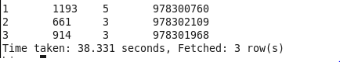

**Without ON clause retrieving columns from right table:**

SELECT r.userid,u.userid FROM ratings_join r LEFT semi JOIN user_join u;

When ON clause is not present in syntax, one can retrieve rows from second table.

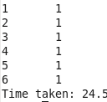

**Illegal:**

**Semi join with where clause denoting columns in Right table and use ON:**

SELECT * FROM ratings_join r LEFT semi JOIN user_join u ON r.userid = u.userid where u.Gender = "M";



**Using ON clause - Returns error while referring columns from right table:**

SELECT * FROM ratings_join r LEFT semi JOIN user_join u ON r.userid = u.userid where u.userid IN (1,2);

SELECT r.userid,u.userid FROM ratings_join r LEFT semi JOIN user_join u ON r.userid = u.userid ;

